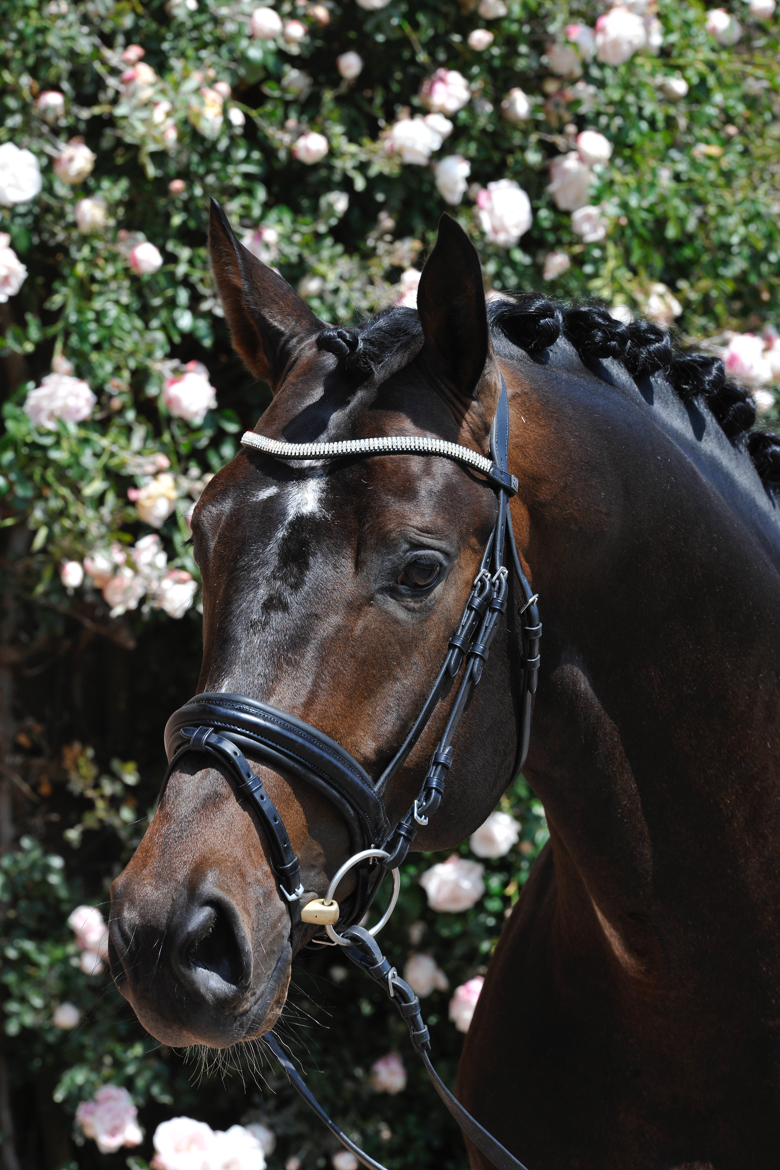
David and Christina Potter


281 Mast Rd. Ext., Durham, NH 03824
Cell: 508-560-4134
netrakehners.com
northeasttrakehners@gmail.com

This contract made and entered into this the day of , 20 , by and between David or Christina Potter hereinafter called "POTTER", having the mailing address hereinabove,
and residing at
Phone #: Fax #: email:
hereinafter called “Purchaser,” for the breeding of Purchaser’s mare (described below) to Marseille, 2010 ATA , Trakehner Verband and RPSI Approved Trakehner Stallion by Prince Patmos (hereinafter referred to as "stallion") subject to the following terms and conditions:

Purchaser’s Mare: Name: DOB:
Color and Description:
Registry: Number:
Sire: Dam:

Fees to be paid in full prior to shipping. Within 10 business days, semen will be shipped to purchasers storage facility at purchasers expense:

- Stallion Service Fee: The normal and customary fees are waived for stallion service won at auction.
- This contract is for: Frozen semen, one dose, stored with Select Breeders Services (SBS) or Peterson and Smith, to be used to inseminate the mare listed above only during this contract year or its consecutive year unless other arrangements are agreed upon in advance between mare and stallion owner. Unused semen may not be used in additional mares without prior approval by POTTER. Should the purchaser use the dose on two or more mares and there are two or more resulting foals, a reduced Stallion Service Fee of $750 will be required along with a second signed breeding contract to receive a breeding certificate for the additional foal(s). There is no live foal guarantee
- Within the continental US, frozen semen handling and shipping costs are approximately $350.00 per tank, including return of the container. Shipping must be arranged in advance.
Veterinarian:
Address:
Phone # / Fax # / Fed Ex Account #
  - Container deposit-$800 refundable: If shipping containers or contents are lost or damaged significantly, the Purchaser shall be responsible for repair or replacement cost thereof. It is required that containers be insured for a minimum $1000.00 (or as recommended by shipper) for frozen containers.
  - Purchaser agrees to return shipping container to SBS as per instructions within two weeks from the date of receiving the container otherwise the container deposit will be forfeited.
  - Stallion services will be provided only to healthy mares in sound breeding condition as determined by the attending veterinarian.
  - SBS agrees to provide detailed instructions for thawing and insemination with the frozen semen as well as providing consulting services with the veterinarian responsible for the insemination.
  - Mare owner will notify POTTER of insemination, pregnancy status and foaling dates.
  - The Purchaser may be required to provide a Mare Health Form, signed by a licensed veterinarian, certifying that the mare is in good physical condition prior to the shipment of semen.
  - The Purchaser shall keep the mare in good physical condition throughout the pregnancy; vaccinated for rhinopeumonitis at 5, 7 and 9 months of pregnancy, and de-wormed regularly.
- It is understood and agreed that this Stallion Service Contract must be used within this year or the next subsequent year or it will be NULL AND VOID, ab initio, AND ALL FEES PAID SHALL BE FORFEITED.
- Other Terms:
1. This contract shall be governed by the laws of the State of New Hampshire, and shall be binding on the parties, their heirs and assigns.
2. This contract may not be assigned or transferred without the written consent of POTTER.
- POTTER is not responsible for any damages which the Purchaser may sustain for lost, damaged or delayed semen, and makes no representations or warranties with respect to any semen furnished hereunder except that it is the semen of the stallion stated herein and that at the time of shipment the semen was suitable for artificial breeding containing a minimum of 600 million sperm and upon thawing>30% motility as predetermined by SBS.
- All mares must receive an ultrasound scan between 14 and 20 days of the last insemination or breeding; palpation test or ultrasound between 30 and 35 days of the last insemination or breeding, and palpation or ultrasound between 50 and 55 days of the last insemination or breeding.

In Witness Whereof the parties have hereunto set their hands and seals.
PURCHASER: ACCEPTED:

DATE: DATE:

Signature of Purchaser Christina UH Potter and/or David C. Potter



Caitlin Walsh
Storage & Distribution Manager
Select Breeders Service, Inc.
961 Cayots Corner Road
Chesapeake City, MD 21915
410-885-3202 /Fax 401-885-3206

